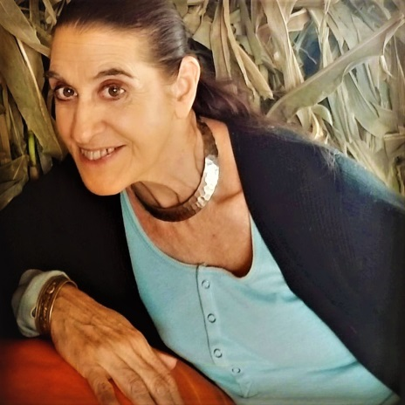

Introducing Salli Squitieri

*Artist Development, Bookings, Management, Promotions, Sales, Consultant, Event Producer*

*Salli enthusiastically and passionately represents her clients and projects in an exceedingly contagious fashion leaving quite a*positive impression on those she encounters.

*For Salli the journey is equally important as the end result therefore her methodology is not about a conquest but rather making a positive difference in the world.*

*She is not afraid of obstacles and always gets the job done.*

*She applies her many experiences to each venture that she approaches. If you tell her it can't be done, she'll take it as a challenge and find a way to do it. She lives a highly principled life and is never without a project.*

*Her beliefs are if you want something "make it happen" and never give up because as the saying goes: Dreams are not just for dreaming but for coming come…*

*Salli Squitieri Telephone 850-570-9465*

*Email: sallisquitieri@yahoo.com*

[**LINKS**](https://www.facebook.com/squitieri.butterfield)

[**https://www.facebook.com/squitieri.butterfield**](https://www.facebook.com/squitieri.butterfield)

[**https://www.linkedin.com/in/butterfieldpbfs**](https://www.linkedin.com/in/butterfieldpbfs)

[**https://twitter.com/ssquitieri**](https://twitter.com/ssquitieri)

[**www.facebook.com/sallisquitieri**](http://www.facebook.com/sallisquitieri)